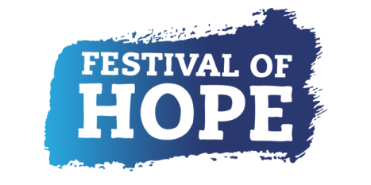
FESTIVAL OF HOPE - COMMISSION OPPORTUNITY:

A short film.

We would like to commission an artist to make a short film that documents people’s experiences of Covid-19 and lockdown in Winsford, Cheshire.

WHO ARE WE?
We are Winsford Young Producers. We are a group of young people working on a “Festival of Hope” for Winsford which will reflect on our heritage, as well as creating a message of hope.

We would like to work collaboratively with the artist so that the commission accurately reflects our community. We will support through the gathering of materials from our community via social media.

ARTIST BRIEF
We would like to commission an artist to work with us and our community to create a new film reflecting the wider experience of contemporary heritage in Winsford.

We are particularly interested in reflecting on and documenting people’s experiences during Lockdown and throughout the pandemic of Covid-19.
We are interested in documenting stories that would otherwise go undocumented and unseen.

We also want to bring people together to show that everyone is going through the same thing, bringing a message of hope by showing a universal experience.

The film will be shown on social media, on our own website and screened in the centre of Winsford town centre, in partnership with a community cinema window, “Cine Window”.

ESSENTIAL EXPERIENCE
-Able to work over video calls

DESIRABLE EXPERIENCE
-Experience of working with young people previously
-Experience of working collaboratively
-Able to support in collecting digital material from the community
-Current DBS check

The chosen artist must be willing to apply for an Enhanced DBS Check. Due to the short time frame, having an up to date DBS check in place would be preferable.

SUPPORT STRUCTURE
The artist will report to Winsford Young Producers, who will approve the work.

The group are supported by a Project Producer, who will support the artist as necessary.

HOW TO APPLY
If you’re interested in this commission please send a brief statement (one side of A4, if written, 2 minutes if recorded), to include:

-An example of a piece of work you are most proud of
-How would you make this commission into your own?
-Why do you want to work on this project?
-A top line breakdown of the budget, to include your daily rate.

Applications can be written, filmed, or an audio recording. They should be sent to festivalofhopecommissions@gmail.com with FILM COMMISSION in the title of the email.

Any questions can be sent to the above email address, you can also arrange a phone call with the project producer, Cathryn Peach-Barnes, via this email.

DEADLINE
Midday 9th July 2020
We would like the piece to be delivered by mid-August.
The first round of shortlisting will be open for two weeks.

BACKGROUND TO THE FESTIVAL OF HOPE.
The Festival of Hope is a pioneering festival that places young people at the heart of design, making, programming and production. The Festival of Hope is part of Hope Streets, a five-year project creating a strategic partnership between heritage and youth sectors in the North West, led by Curious Minds and supported with funding from the National Lottery Heritage Fund.

Winsford Young Producers are supported by West Cheshire Museums, a group of museums operated by Cheshire West and Chester Council. The group includes Grosvenor Museum (Chester), Lion Salt Works (Northwich), Weaver Hall Museum (Northwich) and Stretton Water Mill (Malpas). West Cheshire Museums are committed to showing that young people are truly agents of change; by supporting the amazing things that happen when young people have the power to make decisions.

ARTIST FEE
The budget for this project is: £1,500-£2,500 (including expenses & dependent on experience).
The artist’s fee covers all work relating to the project, the artist will work on a self-employed basis.

SELECTION PROCESS
The commission will be selected through open competition.
Artist applications will be shortlisted by Winsford Young Producers, who will then be in touch to ask any further questions, if necessary, before selecting a final artist.

